2022 Housekeeping Amendment

Reclassification only of the following Council owned sites from Community Land to Operational Land:
Item 1 - 60-62 Main Road, Boolaroo, Lot 4 & 5 Sec E DP 3494
Item 2 – Part of 27C First Street, Cardiff South, Lot 30 DP 196, South of Ada Street
Item 5 - 48 Oakdale Road, Gateshead, Lot 20 DP 1115790
Item 8 - 16 Skye Street, Morisset, Lot 1 Section 12 DP 758707
Reclassification of the following Council owned sites from Community Land to Operational Land and make a range of associated zoning and development standard changes:
Item 3 – 27 First Street, Cardiff South, Lot 1 DP 190522 & 27C First Street, Cardiff South, Lot 30 DP 196, North of Ada Street
Item 4 - 21 Narara Road, Cooranbong, Lots 4, 5, 6 & 7 Section O DP 724
Item 6 - 4a Clare Street, Glendale, Lot 103 DP 553828
Item 7 - 62A Graham Street, Glendale, Lot 62 DP 247342
Item 9 - 38 Alison Street, Redhead, Lot 50 DP 844457
Rezone the following Council owned site and make a range of associated zoning and development standard changes:

Item 10 - 20 Ruttleys Road, Wyee, Lot 495 DP 755242

Part 3 – Justification of Strategic and Site-specific Merit
Section A - Need for the Planning Proposal
- Is the planning proposal a result of an endorsed LSPS, strategic study or report?
The Planning Proposal has not been prepared following any outcomes of a Local Strategic Planning Statement (LSPS), a study or report relevant to the subject properties. These properties have been identified through routine administrative tasks as either administrative anomalies, or as being inappropriate for their current classification, such as difficulties which have been identified relating to access, the size of land having regard to its proposed use (eg. for residential purposes or as public open space), or to align development standards appropriately with the use of the land.
Investigations were undertaken in relation to each property to determine their appropriateness for reclassification. The outcomes of these investigations and reasoning to pursue the proposed amendments are outlined below.
- ITEM 1: 60-62 Main Road, Boolaroo Lot 4 & 5 Sec E DP 3494

This land, which is comprised of lots 4 and 5 as shown in diagram A below, was originally acquired in 1948.

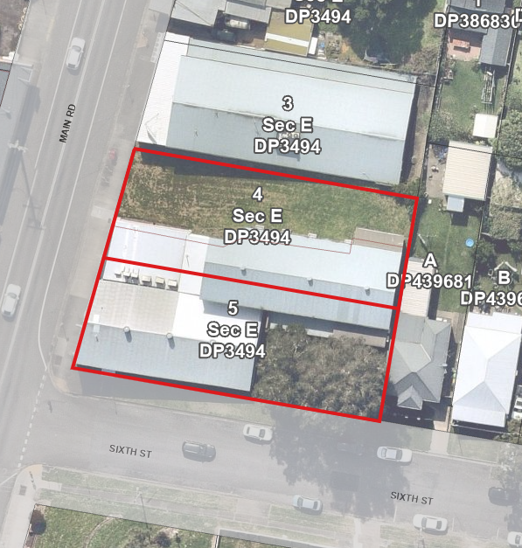
Diagram A – Lots 4 & 5

When the Local Government Act 1993 (the “LG Act”) commenced, part of Lot 4 was vacant open space, and the remainder of Lots 4 and 5 were leased partly as a cinema and partly as a pensioner’s hall. The lease for a cinema has continued since that time, and the part formerly leased as a pensioner’s hall is now leased for use by a disability aid and services provider. A diagram showing the various uses of the land is shown in diagram B below.

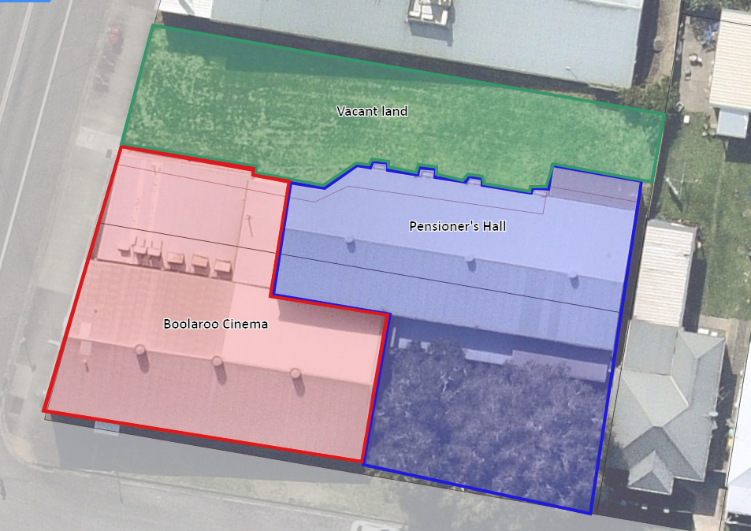
Diagram B – Uses on land

When the LG Act commenced, land which was not classified by Council as operational land became classified as community land automatically under the provisions of that legislation.

Following Council resolution made on 26 July 1993, a statutory notice was published on 1 September 1993 to classify various lands as operational. That notice included reference to the following land:
Part 4/E/3494 60 Main Road, Speers Point
Part 4/3494 60 Main Road, Boolaroo
Part 4/E/3494 62 Main Road, Boolaroo

The references as published contain typographical errors in the title references, and do not adequately describe the land having regard to the use of the land at the time. This has resulted in uncertainty regarding the classification of the land. It is considered likely that the error in the references as published may have resulted from attempting to cater for the different parts of the land (vacant land, cinema and pensioners hall).

Accordingly, this proposal seeks to confirm the classification of both lots 4 and 5 as operational in order to rectify such administrative anomaly, and to appropriately reflect the classification of the land having regard to the existing and proposed continuing use of the land.

- ITEM 2: 27C First Street, Cardiff South, Part of Lot 30 DP 196, South of Ada Street.

The land comprises part of a long narrow strip being the piece south of Ada Street, which is located along the western edge of DP 196, subdivided in 1888, less than 4m wide x 180m long.

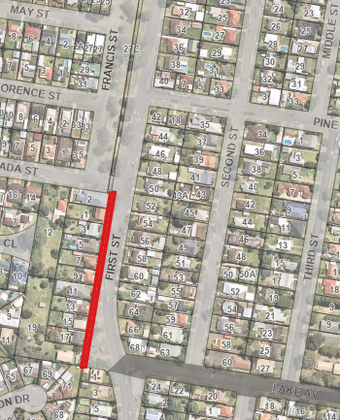
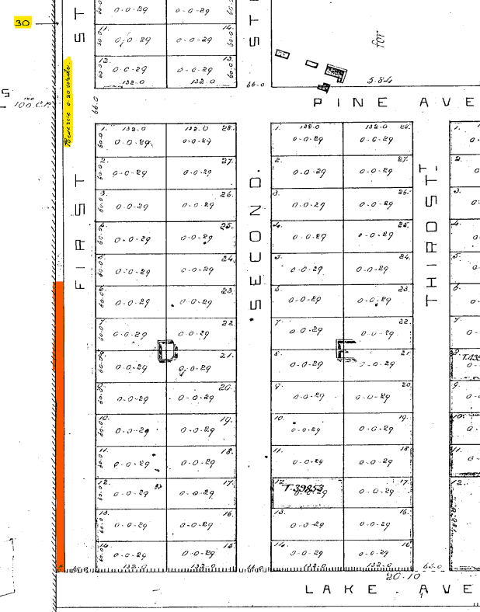
Subject Land
Extract of DP 196 Aerial 2022

It is believed that this land may have been originally formed as part of a spite strip to stop adjoining subdivisions from using the adjoining registered roads thus maximising their housing yields. As the land was unclassified, in 1993 by default it has now automatically become a Community Land classification.

Today, however, this land is now effectively land locking the properties south of Ada Street that face First Street, Cardiff. It is now proposed to reclassify the land from Community Land to Operational Land, then dedicate it as road.

- ITEM 3: 27 First Street, Lot 1 DP 190522 & part of 27C First Street, Lot 30 DP 196, Cardiff South, North of Ada Street

The land comprises of two long narrow strips as follows:
- Part of DP 196, less than 4m wide x 483m long, runs down the western edge of DP 196.
- DP 2742, just over 0.3m wide x 450m long, runs down eastern edge of DP 2742 (now DP 190522)
Historically, these strips of land have prevented east/west vehicular movements and resulted in two roads, Francis and First Street, running parallel with each other. If the strips are removed, then some of the streets can run through to First Street, making Francis Street redundant and freeing up residential land for future development.
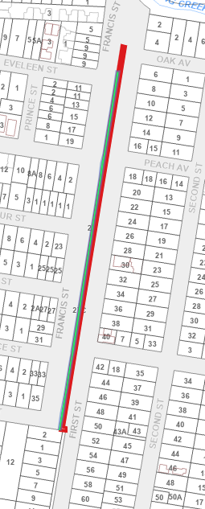
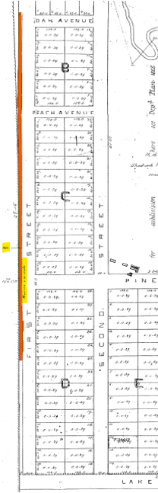
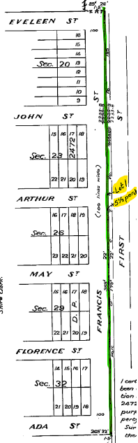
DPs Showing Proposed Land:
Subject Land
27c First St
DP 196
Subject Land
27 First St-Green
27c First St-Red
Subject Land
27 First Street
DP 190522
DP 190522 DP196 Current Cadastre plan

It is now proposed to close part of Francis Street, between Ada and John Streets, extending the residential land to the east to First Street for sale and/or future development. This will require reclassification of the land from Community Land to Operational Land, and rezoning changes to these strips of land to be compatible with the adjoining R3 residential land.

Possible new residential subdivision, shown in red below:
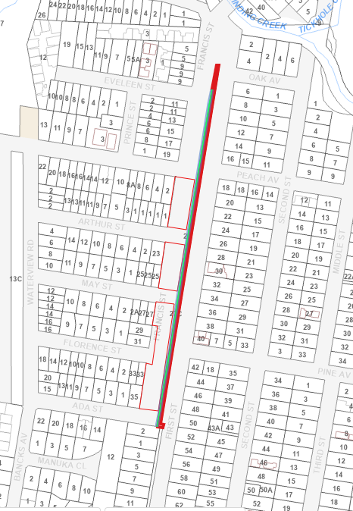
New residential land

- ITEM 4: 21 Narara Road, Cooranbong - Lots 4, 5, 6 and 7 Section O DP 724.

The land was transferred to Council in 2008 from the Federal Government, on the basis that “the lands are to be made available for the use and benefit by the people of Australia as a reserve for the preservation and study of wildlife and retained substantially in its natural state as a retreat for meditation and contemplation.” See Annex H.
The land has been subject to significant disturbance and weed proliferation and being 2,270 m², does not satisfy the minimum area recommended for local parks (5,000m²). It has been identified that the land is not specifically required for recreational purposes for the area.

Accordingly, Council is now considering a land swap for other land it owns nearby at 33 Narara Road which is currently operational land (shown orange) and adjoins community land (shown yellow).

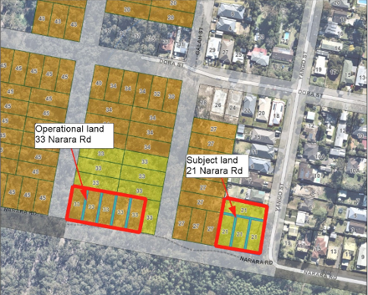

This reclassification land swap would enable the following:

- a single holding of community land with a total area of 7,322.4m², large enough to be developed into a local park. This would be a net increase of community land holding in the area by 354m², being one housing lot.
- the residential development of the southern block between Yango and Gala Streets. After the formation of the southern end of Gala Street and part of Narara Road, this would provide thirteen new residential blocks, and assist in resolving bushfire and land management issues for the existing houses in that block.

The reclassification land swap will result in, and facilitate improved development, larger and more usable local open space and environmental outcomes.

- ITEM 5: 48 Oakdale Road, Gateshead, Lot 20 DP 1115790

Council purchased the land in 1994 (now known as 48 & 52 Oakdale Road) for a waste transfer station which was never developed. Instead a small business centre was developed on the site. Later Council subdivided the land and sold half the site to a private purchaser.
The subject land is now used by the Central Coast Community College. It contains several buildings housing an Administrative Centre which contains two training rooms, three office spaces, reception area, kitchen and toilet amenities. Also located on the land is 10 separate office/classroom spaces, 12 industrial sheds varying in size and approximately 41 carparking spaces.
It has recently been discovered that Council never classified the land upon its purchase in 1994, and accordingly the classification has reverted to Community land. It was clearly intended and has been used as Operational land and does not appear in Council’s generic Plan of Management (PoM) either.
Unfortunately, Council is not authorised to undertake any dealings on the land until it is either classified as Operational land or included in a Plan of Management. Council now proposes to reclassify the land from Community Land to Operational Land to facilitate the current leasing arrangements.

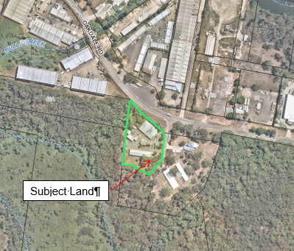

- ITEM 6 - 4a Clare Street, Glendale Lot 103 DP 553828.

This land was dedicated as public reserve under DP 553828 which was registered in 1971. It is unsure why this land was dedicated as public reserve with such a small access handle, being only 4m wide.
The land has been categorised as General Community Use, but no facilities have been provided on it. The properties to the north remain unfenced so it appears that the land is part of their yards. There is a row of scattered shrubs delineating the approximate boundary line and some temporary garden beds, thought to be owned by the residences in front, which are located in the south east corner.
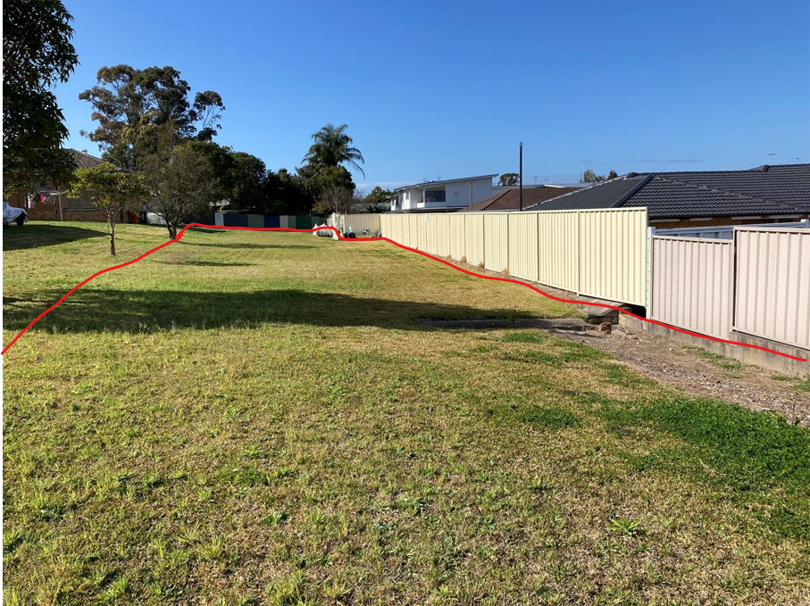
Subject land
Outlined in red
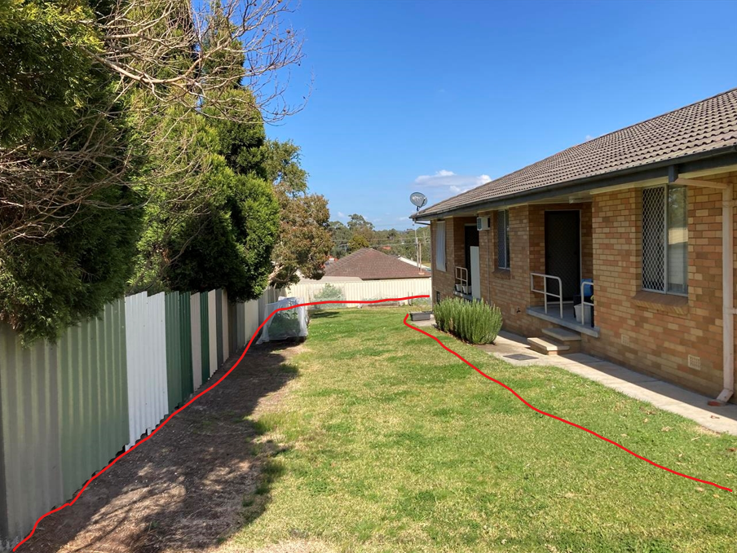
Adjoining owners
Garden beds
4m Access
This land is now surplus to Council’s recreational needs for the area and is proposed to be sold to adjoining owners for residential development. This will require a rezone of the land from RE1 Public Recreation to R3 Medium Density Residential and a reclassification of the land from Community to Operational land.

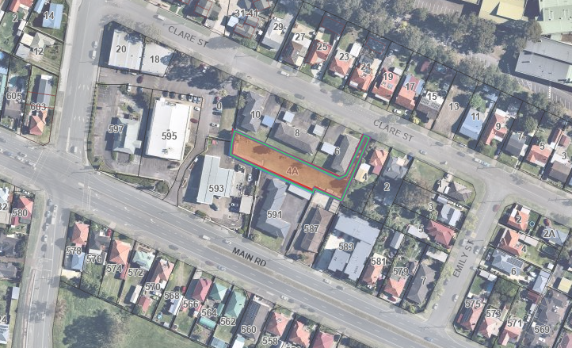
Subject Land

- ITEM 7: 62A Graham Street, Glendale, Lot 62 DP 247342.

The land was dedicated as public reserve under DP 247342. It is a triangular piece of land having an area of 840sqm and fenced in by nine adjoining owners. Its only access is via a long narrow handle, 4m wide by 36m long, between houses with no indication of public land at its end. It is vacant and contains several large trees with mown lawns beneath.

The land is considered surplus to Council’s needs. Due to its poor street frontage it is not considered suitable as a pocket park and would not satisfy the safer by design guidelines. It is also disjointed from other reserves making it unsuitable as a bushland reserve or wildlife corridor.
Accordingly, it is proposed to rezone the land for residential use in accordance with the surrounding area for sale or redevelopment. This will require a rezone of the land from RE1 Public Recreation to R2 Low Density Residential and a reclassification of the land from Community to Operational land.

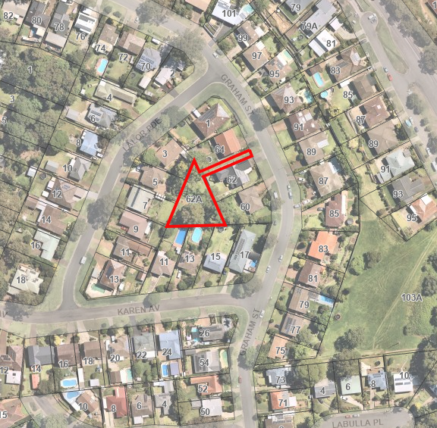
Subject land

- ITEM 8: 16 Skye Street, Morisset, Lot 1 Section 12 DP 758707

Council acquired the land known as 16 Skye Street, Morisset (Lots 1, 2 & 3, Section 12, DP 758707), over the period from 1966 through 1969, for non-payment of rates.
Until recently, the land had no road access and no services available to the site. Council has now approved a residential subdivision in the same street that has now provided both street access and services along the road corridor.

All three lots are surplus to Council’s requirements and were intended to be listed as Operational land in 1993. Unfortunately, Lot 1 Section 12 DP 758707 was not included in the advertisement and as a result automatically defaulted to Community Land classification. This administrative error is now proposed to be addressed through reclassification of Lot 1, Section 12, DP 758707 from Community Land to Operational Land, which will allow for sale and/or development of the land by Council.

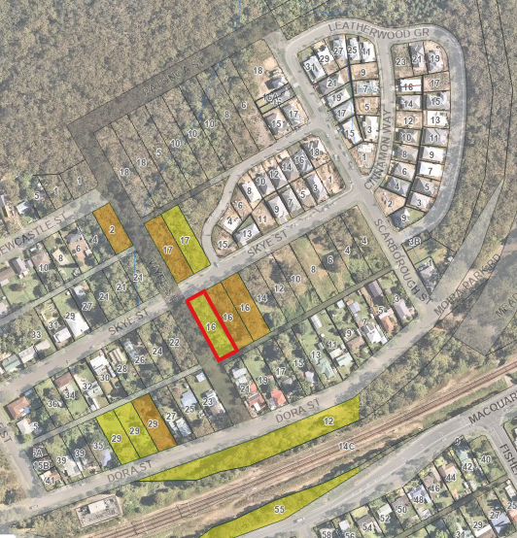
Recent subdivision
Subject land
Council owned land shown coloured. Yellow – Community land. Orange – Operational land.

As Lot 1 adjoins the unformed road of Wyee Street, it has several constraints that may stop construction on this land, but could aid in developing the adjoining two lots to the east if all sold together. These constraints include a riparian zone for water course running down Wyee Street, the need for an Asset Protection zone (bushfire threat shown by red arrows) and threatened ecological communities (shown black hatched):

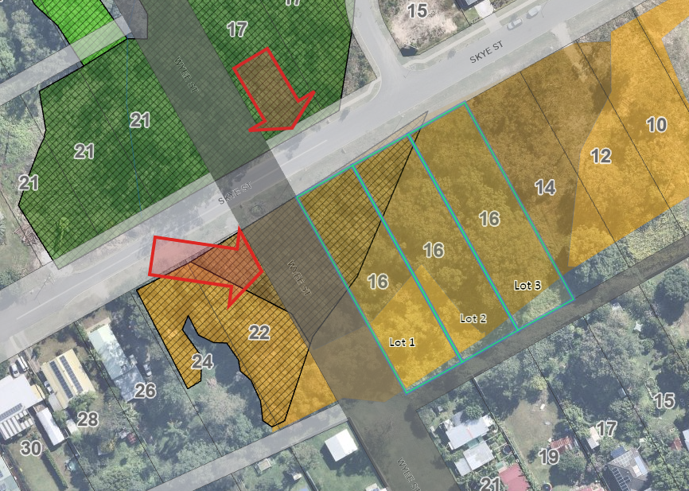
- ITEM 9: 38 Alison Street, Redhead Lot 50 DP 844457

This land originally was part of Scrubby Street which formed the southern extremity of the original subdivision plan created in 1894 being the Redhead Township plan DP 3109. In 1965 DP 3109 was connected to the adjoining subdivision DP 13639 on the western side of Freshwater Creek via Beach Road which was located further to the south at its Alison Street intersection. Later, around 1980, Scrubby Street was closed which left this residue piece of land, which by default has become community land as it was unclassified.
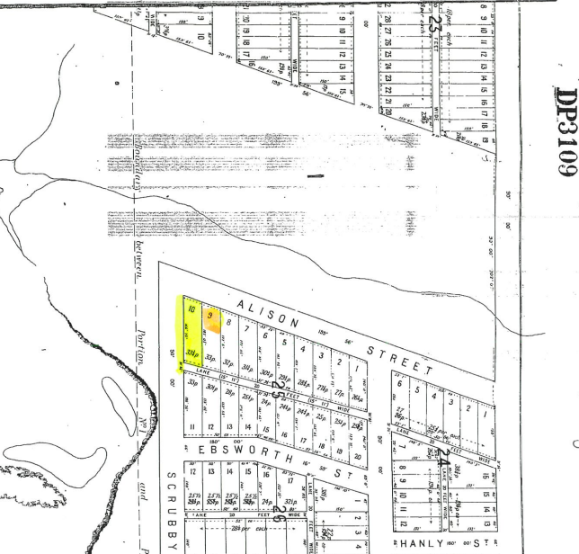
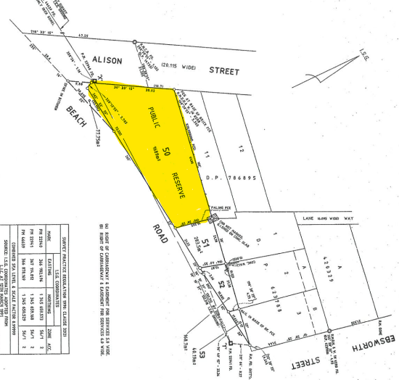
Extract from DP 844457 showing Beach Road and public reserve
This land is now surplus to Council’s recreational needs for the area and is proposed to be sold for residential development. This would require the land to be rezoned from RE1 Public Recreation to R2 Low Density Residential and reclassified from Community Land to Operational Land, which will allow for sale and/or development of the land by Council.
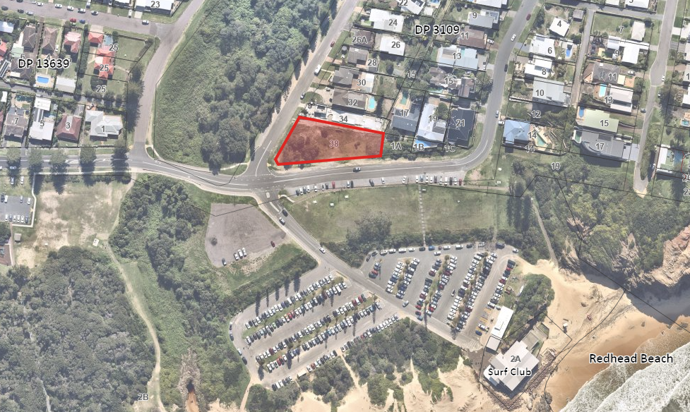
Subject land

- ITEM 10: 20 Ruttleys Road, Wyee, Lot 495 DP 755242

The land was acquired by Council in the 1980s, and used as a septic tank effluent disposal area until the mid-1990s. It contained a ponding system and absorption beds located within the RU6 zoned land. These two areas are heavily disturbed with heavy weed infested regrowth.

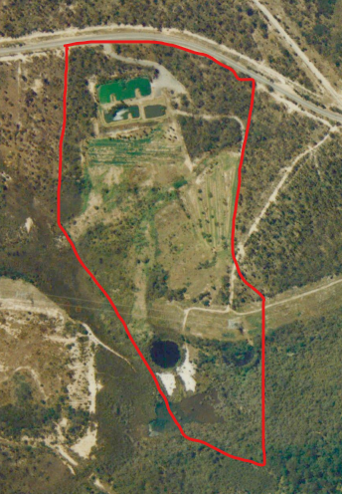
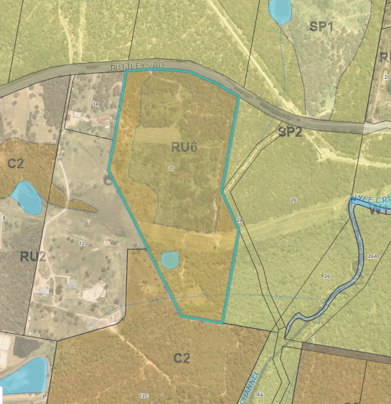
Subject land
Current zoning - RU6 Zone over previously disturbed area 1993 aerial showing septic tank effluent disposal area
The land has frontage to Ruttleys Road and has a sealed bitumen road linking the two disturbed areas. A transmission line easement (60.96m wide) crosses the land east/west, about 450m south of Ruttleys Road, separating the rear 180m of the site.
Outside of the disturbed areas, the northern part (closest to Ruttleys Road) contains Angophora inopina and Tetratheca juncea, while the southern part of the land contains EEC (Swamp Sclerophyll Forest over Floodplains). These areas are not impacted by the proposal.
A bushfire hazard assessment determined that future development on the site would be able to provide sufficient APZs within the disturbed areas to achieve BAL 29, without impacting valuable native vegetations areas around the disturbed areas.
A contamination assessment (including DSI and site audit) has determined the site is potentially suitable for rural residential development, subject to appropriate remediation.

This land is already operational land, however it is now proposed to rezone the land from RU6 Transition to C4 Environmental Living, which will maintain the land as a transition area between Wyee and Wyee Point. The C2 zoning on the land will remain.

